VPC-CHALLENGES
- Design and deploy a scalable network architecture using AWS Transit Gateway to simplify network connectivity between multiple VPCs.

VPC Setup Overview
VPC Name | CIDR | Region
my-vpc-01 | 172.168.0.0/24 | Europe (Stockholm)
vpc-2 | 10.0.0.0/28 | Europe (Stockholm)
vpc-3 | 10.0.1.0/28 | Europe (Stockholm)
vpc-4 | 10.0.2.0/28 | Europe (Stockholm)

Step-1: Create Subnets in Each VPC
Example:
VPC | Subnet CIDR
my-vpc-01 | 172.168.0.0/26
vpc-2 | 10.0.0.0/28
vpc-3 | 10.0.1.0/28
vpc-4 | 10.0.2.0/28
Each subnet must be Available and auto-assign IPv4 turned ON if public.

Step-2: Launch EC2 Instances (1 per VPC)
Instance Name | VPC | Private IP Example
vpc-1-ec2 | my-vpc-01 | 172.168.0.6
vpc-2-ec2 | vpc-2 | 10.0.0.12
vpc-3-ec2 | vpc-3 | 10.0.1.46
vpc-4-ec2 | vpc-4 | 10.0.2.13
All in running state
Allow SSH with your key pair

Step-3: Create Transit Gateway (TGW)
VPC Console → Transit Gateways → Create TGW

Step-4: Create TGW Attachments for Each VPC
Transit gateway attachments → Create attachment
Attachment Name | VPC
vpc-1-tga | my-vpc-01
vpc-2-tga | vpc-2
vpc-3-tga | vpc-3
vpc-4-tga | vpc-4
State shows Available

Step-5: Update Route Tables in Each VPC
Example Routing (for vpc-2 route table)
Destination | Target
10.0.0.0/28 | local
10.0.1.0/28 | Transit Gateway
10.0.2.0/28 | Transit Gateway
172.168.0.0/24 | Transit Gateway
Repeat same logic:
Routing summary
VPC | Needs route to | Target
my-vpc-01 | All 10.0.x.x CIDRs | TGW
vpc-2 | 172.168.0.0/24 & other 10.x | TGW
vpc-3 | 172.168.0.0/24 & other 10.x | TGW
vpc-4 | 172.168.0.0/24 & other 10.x | TGW
Save routes on all VPC route tables

Step-6: Modify Security Groups
Edit inbound rules to allow internal network:
Type | Port | Source
All Traffic | All | 172.168.0.0/16
All Traffic | All | 10.0.0.0/24
This allows ping/SSH inside the TGW network

Step-7: Connectivity Test Between VPCs

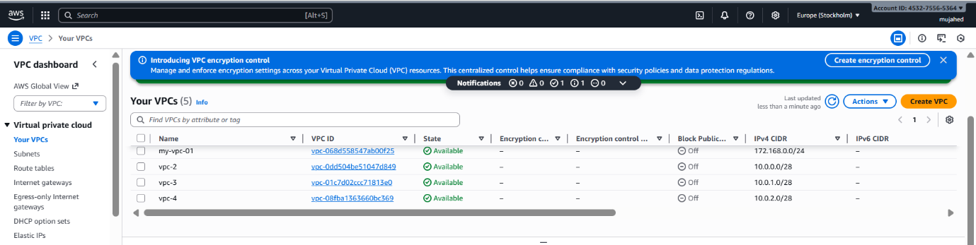

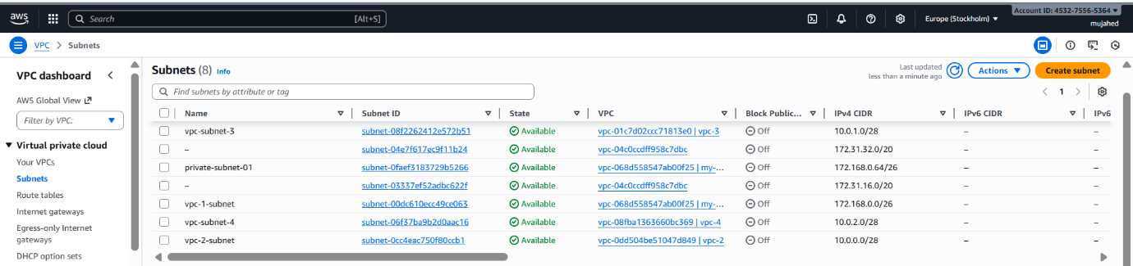

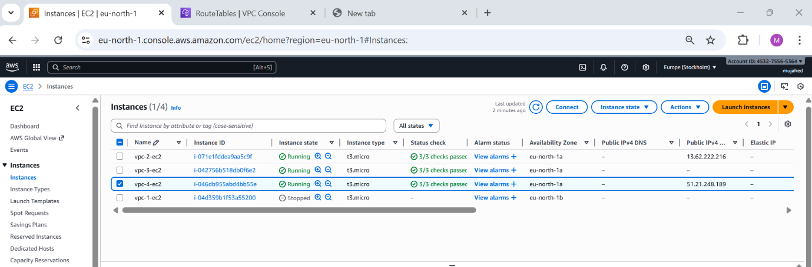

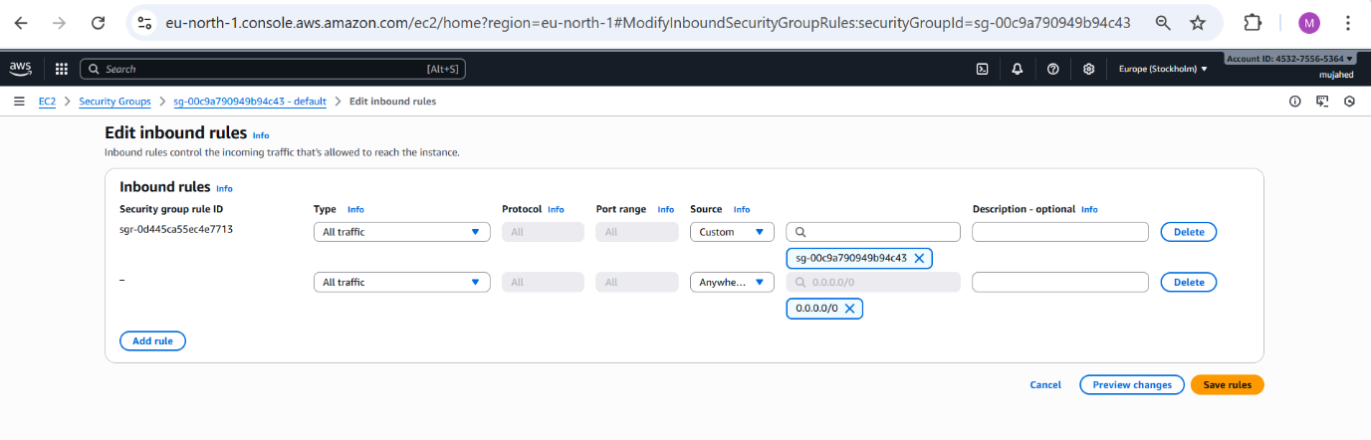

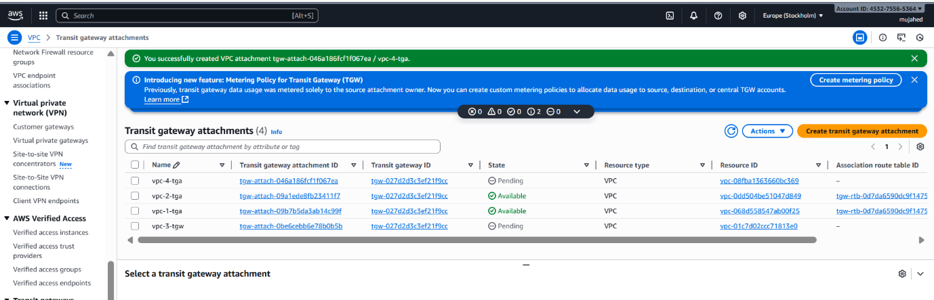

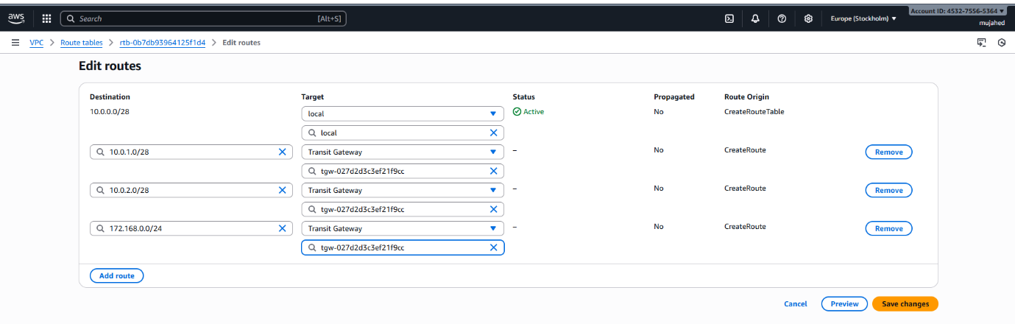
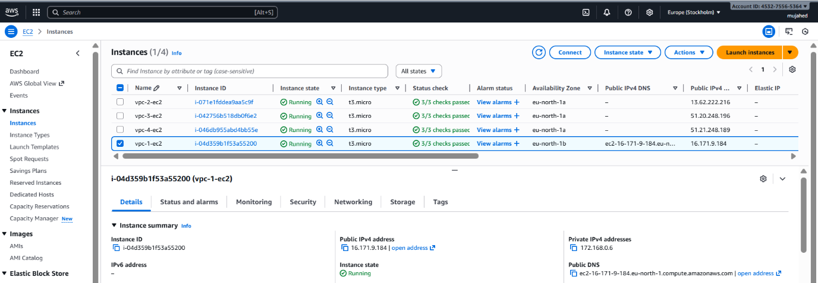

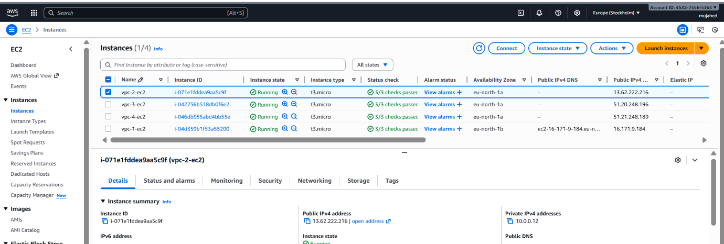

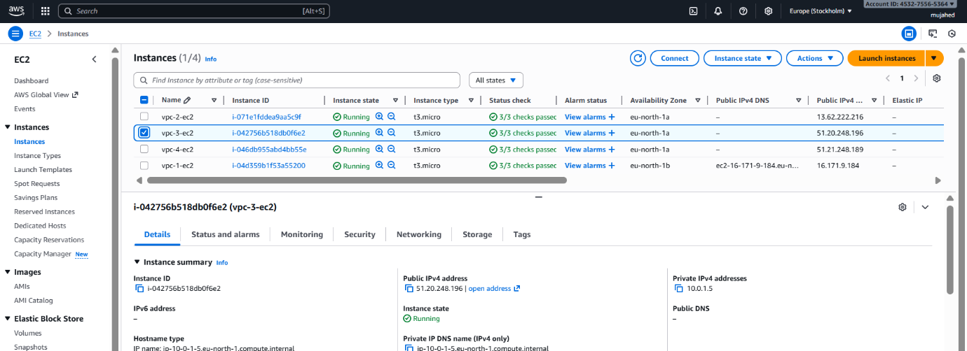

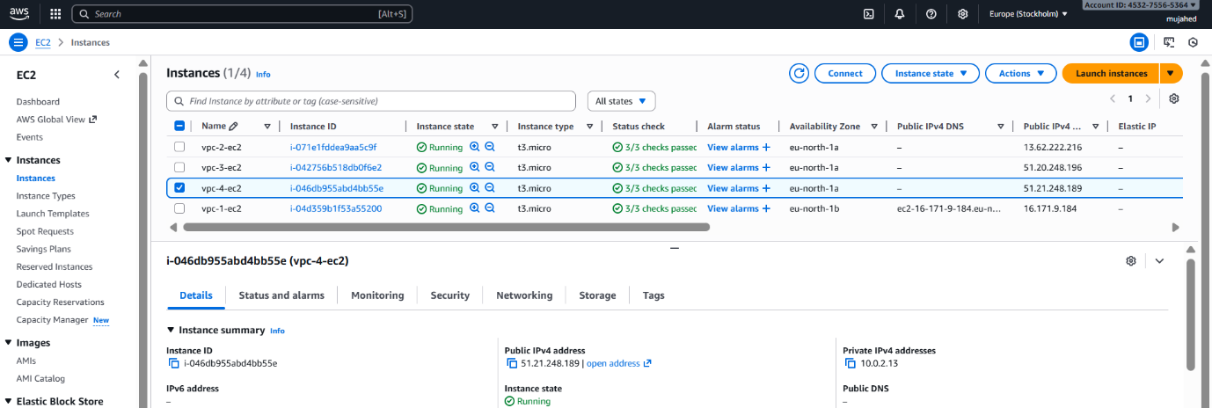

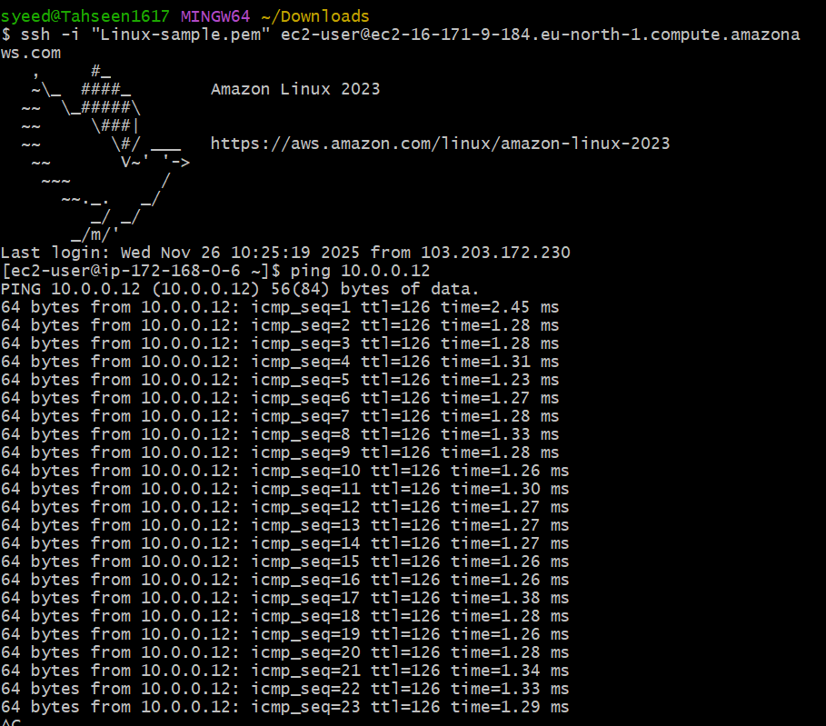

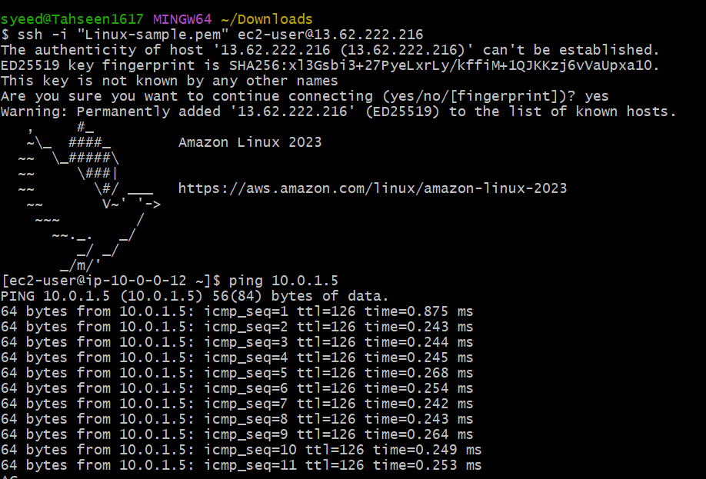

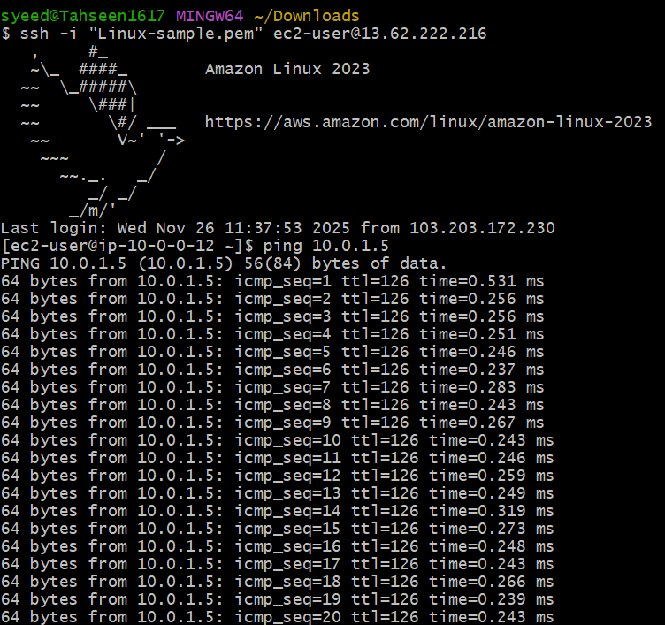

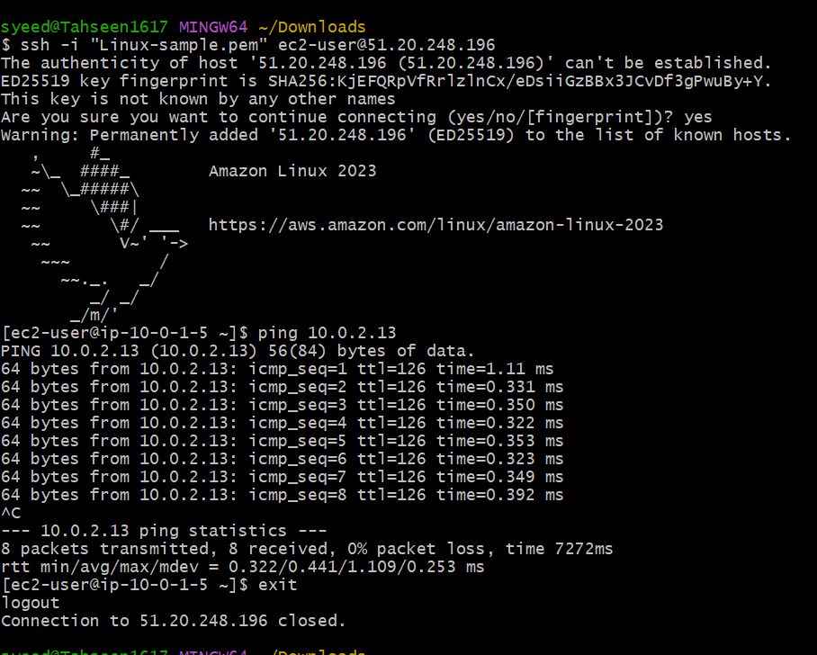

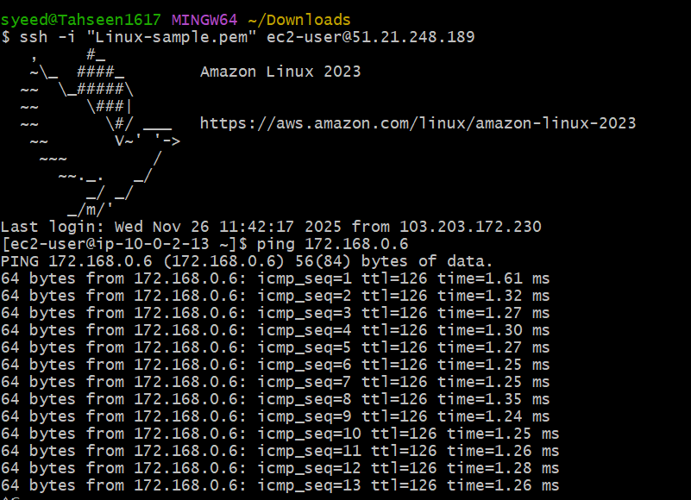

- Configure VPC endpoints to securely access AWS services without internet gateways or NAT gateways, ensuring data privacy and minimizing exposure to external threats.

Step-1: Create S3 Bucket
AWS Management Console → S3 → Create bucket
Fill in:
Field | Value
Region | Europe (Stockholm) eu-north-1
Bucket type | General purpose
Bucket name | my-s3-bucket-mujju
Block Public Access | Enabled (default recommended)
Click Create bucket
S3 bucket successfully created

Step-2: Create AWS Access Key
IAM → Security credentials → Create access key (root/ IAM user)
You generated:
- Access Key ID
- Secret Access Key
download the .csv file
Step-3: Configure AWS CLI on EC2 Instance
SSH into EC2:
ssh -i "linux-sample.pem" ec2-user@<EC2-Public-IP>
Run AWS configure:
aws configure
Enter the credentials:
AWS Access Key ID: <your-access-key>
AWS Secret Access Key: <your-secret-key>
Default region: eu-north-1
Default output format: json
Verify S3 access:
aws s3 ls
Bucket visible

Step-4: Create VPC S3 Endpoint
VPC Console → Endpoints → Create endpoint
Endpoint name: my-endpoint
Service category: AWS services
Search for S3 service:
com.amazonaws.eu-north-1.s3
Select Type: Gateway
Choose VPC:
vpc-068d558547ab00f25 (my-vpc-01)
Select Route Tables:
private-rt
public-rt
Policy: Full access (default)
Click Create endpoint
Endpoint created successfully

Step-5: Test Private Access to S3 (No Internet Required)
From private subnet instance or same EC2:
aws s3 ls
Success again
This confirms:
- S3 is reachable privately
- EC2 uses VPC Endpoint, not the Internet

